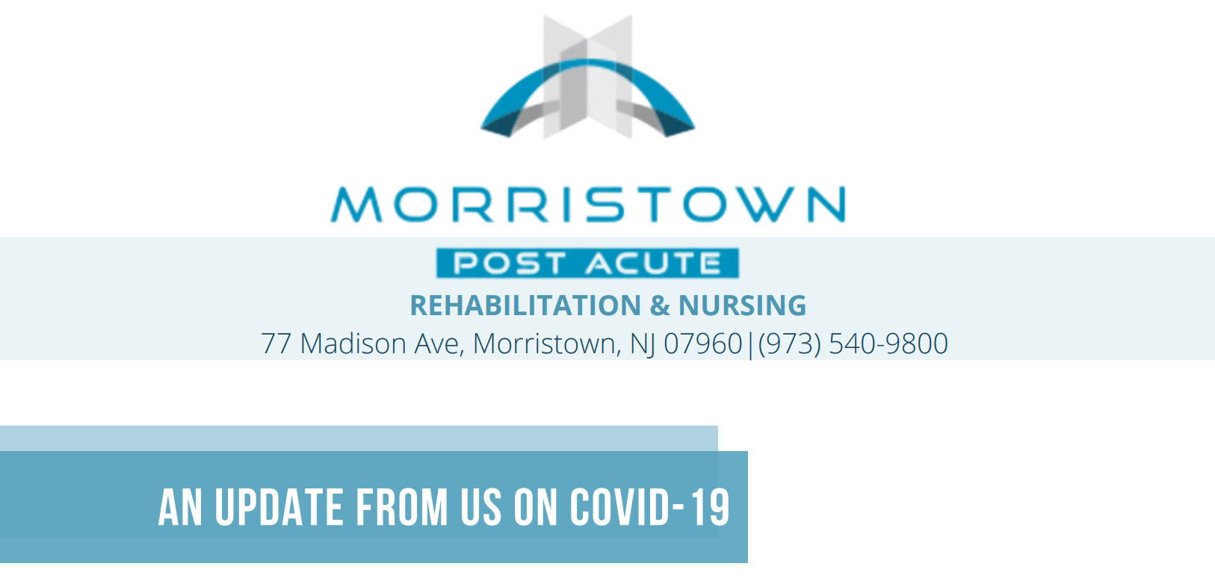
Dear Residents, Families and Staff,
TODAYS DATE: 1/2/2023

We are currently in outbreak status.

All of our staff members continue to follow public health recommendations to reduce the risk of spreading COVID-19 and continue to enforce aggressive infection control measures. These include strict handwashing procedures, wearing facemasks at all times, and deploying additional personal protective gear when interacting with residents who are sick. Residents are being monitored for signs and symptoms of COVID-19, and employees are being screened before reporting to duty and throughout the day of their shifts. Employees are wearing masks and face shields when on duty and appropriate PPE when working closely with residents.

We know this is a difficulty time for everyone. We will continue to provide the best quality of care to our residents. We encourage you all to keep our residents and staff members in your thoughts and prayers.
We also recommend that if you are not feeling well or have been exposed to someone who is ill, to refrain from visiting until you are feeling better. Until you are feeling better, we can arrange for Facetime visits or telephone calls. Feel free to call me directly if you need assistance and please do not hesitate to reach out to us with any questions or concerns you may have.

Thank you,

Yosef Rosenberg, LNHA
Administrator

Residents:
Total: 18
Covid positive: 10
Hospitalization: 3
Deaths: 0
Resolved: 5
Staff:
Total: 6
Covid positive: 1
Recovered: 5

